Project Design Phase-II
Data Flow Diagram & User Stories

Date | 02 December 2025
Name | Premasagar K
Team ID
Project Name | Book Store App
Maximum Marks | 4 Marks

Data Flow Diagrams:
A Data Flow Diagram (DFD) illustrates how data moves within the Online Book Store platform. It captures how users (customers, sellers, and admins) interact with the system, how information flows between different modules, and where the data is stored.
Example: DFD Level 0 (Industry Standard)

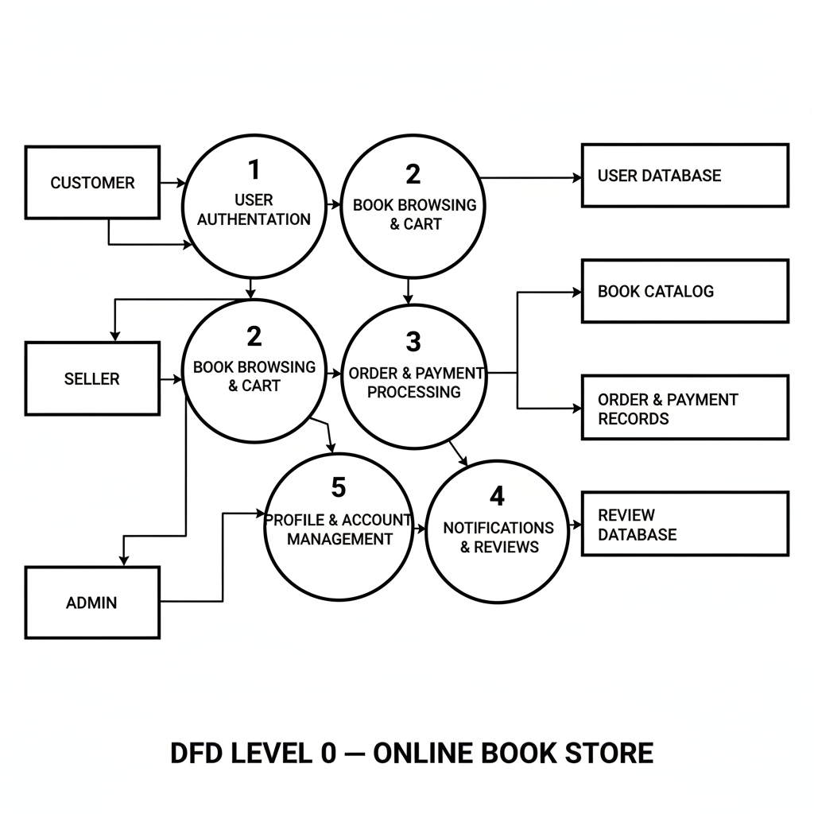

User Stories

User Story Table –Book Store

User Type | Functional Requirement (Epic) | User Story / Task | Acceptance Criteria | Priority | Release
Customer | User Registration & Login | As a customer, I can create an account using email so that I can buy books online. | Account created, confirmation message shown, data stored in DB. | High | Sprint-1
Customer | User Registration & Login | As a customer, I can log in and log out securely. | Correct credentials allow access; logout ends the session. | High | Sprint-1
Customer | Browse & Search Books | As a customer, I can search books by title, author, or category. | Search results list relevant books within 1–2 seconds. | High | Sprint-1
Customer | Browse & Search Books | As a customer, I can filter books by price, language, and rating. | Applied filters update the results correctly. | Medium | Sprint-2
Customer | Cart & Wishlist | As a customer, I can add books to my cart and update quantities. | Cart shows correct items, quantities, and totals. | High | Sprint-1
Customer | Cart & Wishlist | As a customer, I can add books to a Wishlist to buy later. | Wishlist persists after logout and login. | Medium | Sprint-2
Customer | Checkout & Payments | As a customer, I can place an order and pay online securely. | Payment success creates an order and shows confirmation page. | High | Sprint-1
Customer | Order Tracking | As a customer, I can view my past orders and current order status. | Order list shows status (Pending, Shipped, Delivered, Cancelled). | High | Sprint-2
Customer | Ratings & Reviews | As a customer, I can rate and review books I purchased. | Review appears on the book detail page after submission. | Medium | Sprint-3
Seller | Seller Registration & Login | As a seller, I can register and log in to manage my books. | Verified seller can access seller dashboard. | High | Sprint-1
Seller | Book Listing Management | As a seller, I can add new books with details and images. | New book appears in catalog and seller product list. | High | Sprint-2
Seller | Book Listing Management | As a seller, I can edit price, stock, and description of my books. | Changes are reflected in catalog and visible to customers. | High | Sprint-2
Seller | Order Management | As a seller, I can view orders that include my books. | Seller order list shows only that seller’s orders. | High | Sprint-2
Seller | Order Management | As a seller, I can update order status (Processing, Shipped, Delivered, Cancelled). | Updated status is visible to customer in order tracking. | High | Sprint-2
Admin | User & Seller Management | As an admin, I can approve or block sellers and users. | Approved/blocked status is enforced in login and actions. | High | Sprint-1
Admin | Catalog & Category Management | As an admin, I can manage book categories and featured sections. | Categories appear correctly on the homepage and filters. | Medium | Sprint-3
Admin | Reporting & Monitoring | As an admin, I can view reports of sales, top books, and active users. | Reports show accurate aggregated data for a selected period. | Medium | Sprint-3

